

BACHELOR OF COMPUTER SCIENCE
(GRAPHICS AND MULTIMEDIA SOFTWARE)
WITH HONOURS COMPUTING

SEMESTER I SESI 2025/2026

ASSIGNMENT 3

SECP 1513 TECHNOLOGY AND INFORMATION SYSTEM
SECTION 09

GROUP NAME : GROUP 6

GROUP MEMBER : HONG GRACE ENYING A25CS5007
HONG WEI YANG A25CS5027
HEW SIANG LING A25CS5006
GUAN, DERONG A25CS5052

LECTURER'S NAME: DR SURIATI BINTI SADIMON
Description of Speaker Experience
TS. HJ. Abdul Alim bin Abdul Muttalib, Head of Technology and Innovation of Serunai Commerce Sdn Bhd, is an alumnus of Universiti Teknologi Malaysia (UTM), graduating in 2015, giving a talk about Software Development Life Cycle (SDLC) to emphasize to juniors to obtain a better understanding before starting Final Year Project (FYP) and graduating.
What is Project Management and System Development?
Project Management (PM) is about controlling chaos and team synergy. This ensures the project always stays on track, on time and within budget. Additionally, these skills will be beneficial for coordinating effectively with designers, testers and other developers, especially when working independently.
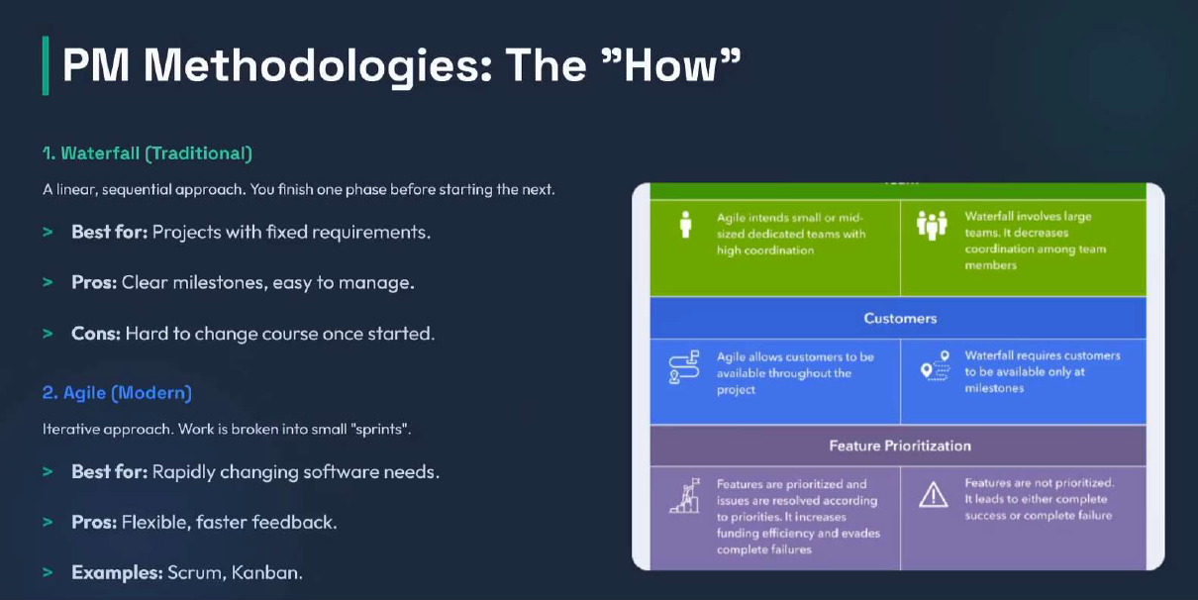
Figure 1: PM Methodologies from the slide of TS. HJ. Abdul Alim
System Development (SD) encompasses the entire process of defining, designing, testing and implementing a software application. For example, Alia is planning to make nasi lemak for breakfast. Before cooking, she needs to define the ingredients, determine the steps to follow, prepare nasi lemak and identify areas for improvement. Without the process, the project will have chaos, bugs and even failure.
Software Development Life Cycle (SDLC)
It involves a cycle used in software development, encompassing planning, analysis, design, implementation, and maintenance.
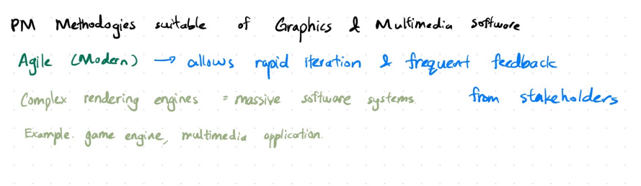
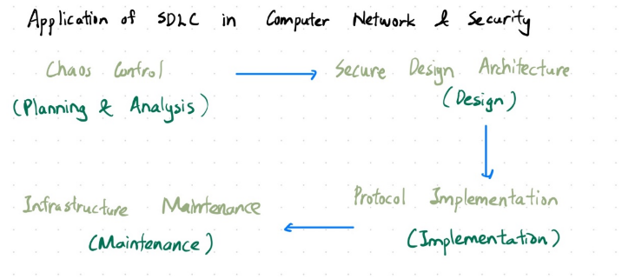
Applications of Project Management & System Development in Fields
Figure 3: Brainstorming about PM Methodologies in Graphics & Multimedia Software

Figure 2: Brainstorming about SDLC in Network Security
Personal Reflections
Hew Siang Ling: I realized that system development or design is not just about writing code. The SDLC framework made me realize the importance of our undergraduate graduation projects and future careers. What impressed me most was the concept of agent coding. This involves utilizing AI tools to automate repetitive coding tasks, enabling me to concentrate on system architecture—not just as a programmer, but also as a designer and manager of complex systems. From now on, I will apply these principles to avoid falling into "design traps" and create a portfolio that fully demonstrates my technical and managerial abilities.
Guan, Derong: Software development is a marathon, not a sprint. Without a thorough proper and systematic blueprint, elegant code is just a house built on sand. Start to think like a System Architect now before FYP arrives. By adopting an Agile mindset and leveraging AI to enhance productivity, I can focus on the real challenge: designing high-level systems that are effective and efficient. This helps me to build the foundational skills to thrive in the future tech landscape.
Hong Grace Enying: I gained a clearer understanding of the SDLC. I believe this can also be applied in everyday life. Following the SDLC roadmap provides a more systematic approach to learning and developing a healthy lifestyle. It offers a significant boost for individuals who are procrastinating and struggling to transform their lives. I believe that implementing this cycle in our lives definitely yields positive outcomes in terms of learning and developing our personality and skills before entering society.
Hong Wei Yang: Throughout the study of TIS, activities such as industrial talks, industrial visits, PC assembly and Design Thinking assignments helped me gain a more comprehensive and systematic understanding of the modern IT industry. From a networking perspective, these activities successfully connected theoretical knowledge with current technologies and real workplace requirements.

List of References
Morley, J. (2023). The University of Manchester 1824. Retrieved from Academic Phrasebank: https://www.phrasebank.manchester.ac.uk/
Muttalib, T. H. (2026). Project Management and System Development. Malaysia.

